AI-Powered Job Recruitment & Candidate Management System (AIRCMS)

Phase 1: Requirement Collection & Analysis — Defining Project Scope & Objectives

Document Title: Phase 1 – Requirement Collection & Analysis
Project Name: AI-Powered Job Recruitment & Candidate Management System (AIRCMS)
Platform: Salesforce CRM with Agentforce AI

1. Introduction
The AI-Powered Job Recruitment & Candidate Management System (AIRCMS) is a Salesforce-based enterprise recruitment platform designed to intelligently manage the complete end-to-end hiring lifecycle. In today's competitive talent market, organizations face significant challenges in managing high volumes of candidate applications, ensuring consistent hiring decisions, and maintaining a structured, transparent recruitment process.
AIRCMS addresses these challenges by centralizing all recruitment activities — from candidate application and initial screening to interview management, offer approval, and onboarding — into a single, intelligent Salesforce workspace. The system eliminates manual resume screening and inconsistent hiring decisions by introducing AI-driven candidate scoring, automated workflows, and structured approval processes.
This document represents Phase 1 of the AIRCMS project, focusing on Requirement Collection and Analysis, specifically the definition of project scope and objectives. It serves as the foundational blueprint that guides all subsequent phases of development, configuration, and deployment.

2. Project Background & Problem Statement
Traditional recruitment processes are largely manual, fragmented, and prone to inconsistency. Recruiters spend excessive time screening resumes, scheduling interviews, and following up on approvals — tasks that can be significantly streamlined through intelligent automation. Hiring managers often lack real-time visibility into candidate status, evaluation outcomes, and offer approvals, leading to delayed decisions and poor candidate experience.
AIRCMS is conceived to solve these core problems by building a Salesforce-native recruitment system that:
- Centralizes all candidate, job, and hiring data in one platform
- Automates repetitive recruitment tasks using Salesforce Flows
- Introduces AI-driven candidate evaluation using Agentforce AI
- Enforces governance and approval controls through structured workflows
- Provides role-based access to protect sensitive hiring data.

3. Project Scope
3.1 Scope Definition:
The AIRCMS project scope covers the complete design, configuration, and deployment of a Salesforce-based recruitment management system. The solution is built exclusively using Salesforce Admin capabilities — including declarative tools, Flow Builder, Approval Processes, Lightning Experience, and Agentforce AI — without any custom Apex development.
The system supports the full recruitment lifecycle across the following stages:
Candidate → Screening → Interview → Offer → Hiring
3.2 In-Scope Components:
The following functional areas and technical components are included within the project scope:
a) Recruitment Data Model:
- Custom Salesforce objects for Candidate Profiles, Job Openings, Applications, Interview Records, and Offer Details
- Defined relationships between objects to represent the complete hiring pipeline
- Custom fields for AI scoring, hiring status, risk indicators, and recruiter assignments
b) Candidate & Job Management:
- Creation and management of candidate records with detailed profile information
- Job opening records linked to departments, locations, and hiring managers
- Application tracking linking candidates to specific job openings

c) Interview Process Management:
- Structured interview stage tracking (Telephonic, Technical, HR, Final)
- Interview scheduling and outcome recording
- Automated status updates based on interview results

d) Offer & Approval Workflow:
- Offer record creation with salary details and terms
- Multi-level approval process for offer authorization
- Automated notifications to hiring managers and candidates upon approval or rejection

e) AI-Driven Hiring Intelligence (Agentforce AI):
- AI-generated candidate scoring based on profile and job fit
- Hiring risk analysis and recommendation flags
- Automated candidate summaries visible directly on Salesforce records
f) Automation via Salesforce Flows:
- Automated candidate screening based on defined criteria
- Interview scheduling reminders and follow-up alerts
- Status update triggers across the recruitment pipeline
- Recruiter task creation and escalation flows

g) Security & Role-Based Access Control:
- Profiles and Permission Sets for Recruiter, Hiring Manager, and HR Admin roles
- Record-level access using Sharing Rules and Organization-Wide Defaults (OWD)
- Field-level security to protect sensitive salary and evaluation data

h) Dashboards & Reporting:
- Recruiter dashboards for pipeline visibility
- Hiring manager dashboards for offer and approval tracking
- Standard reports for recruitment metrics and performance analysis

3.3 Out-of-Scope
The following are explicitly excluded from the current project scope:

- Custom Apex code, Visualforce pages, or Lightning Web Components (LWC) development
- Integration with external job portals or third-party HR systems
- Payroll processing or post-onboarding employee management
- Mobile application development
- Real-time video interview functionality

4. Project Objectives
The AIRCMS project is guided by five core objectives that together define the intended outcomes of the system.
4.1 Centralized Recruitment Management:
Objective: Provide a single, unified Salesforce platform to manage all recruitment activities.
The system consolidates all hiring data — candidate profiles, job openings, applications, interview stages, offer details, and AI-generated recommendations — into one centralized platform. This eliminates data silos, reduces duplication, and gives all stakeholders a single source of truth for recruitment information.
Key outcomes:
- All candidate and job data accessible within Salesforce
- Complete hiring pipeline visible on a single screen
- Elimination of spreadsheet-based or email-driven recruitment tracking

4.2 Automation of Recruitment Workflows:
Objective: Streamline repetitive recruitment tasks through intelligent workflow automation.
Using Salesforce Flow Builder, the system automates key steps across the recruitment lifecycle, including candidate screening, interview scheduling reminders, offer approval routing, recruiter follow-up tasks, and status update notifications. This reduces manual workload for recruiters and ensures timely action at every stage of the pipeline.
Key outcomes:
- Reduction in manual data entry and follow-up tasks
- Consistent, rule-based processing of candidate applications
- Faster time-to-hire through automated stage progression

4.3 Implementation of Salesforce CRM Fundamentals in Hiring:
Objective: Apply core Salesforce CRM capabilities to the recruitment domain.
AIRCMS leverages standard Salesforce CRM features — including custom objects, relationships, validation rules, page layouts, and Lightning App configuration — to build a structured and scalable recruitment application. This objective ensures the system is built on a solid CRM foundation that is maintainable and extensible by Salesforce admins.
Key outcomes:
- Properly modeled recruitment data with defined object relationships
- Validation rules ensuring data integrity across all records
- Lightning Experience configured for recruiter and manager usability

4.4 AI-Driven Candidate Evaluation:
Objective: Use Agentforce AI to deliver intelligent hiring recommendations and risk insights.
The system integrates Agentforce AI to automatically evaluate candidates based on their profiles, experience, and job requirements. AI-generated scores, hiring recommendations, and risk flags are displayed directly on candidate records, enabling recruiters and hiring managers to make faster, more informed decisions without subjective bias.
Key outcomes:
- AI candidate scoring visible on every candidate record
- Hiring risk analysis highlighting potential concerns
- Automated candidate summaries for quick recruiter review
- Priority indicators to rank and filter candidates effectively

4.5 Security, Governance & Approval Enforcement:
Objective: Ensure controlled access to hiring data and enforce structured approval decisions.
AIRCMS implements comprehensive security using Salesforce's role hierarchy, profiles, permission sets, sharing rules, and field-level security. Multi-step approval processes enforce governance over offer decisions, ensuring that no offer is extended without proper authorization from designated hiring managers and HR leads.
Key outcomes:
- Role-based visibility ensuring recruiters see only relevant records
- Sensitive salary and evaluation fields restricted to authorized users
- Offer approval workflows preventing unauthorized hiring decisions
- Audit trail maintained for all approval actions
5. Project Approach & Methodology
AIRCMS is developed using a phased, admin-first approach with no dependency on custom code. The project follows four defined phases:
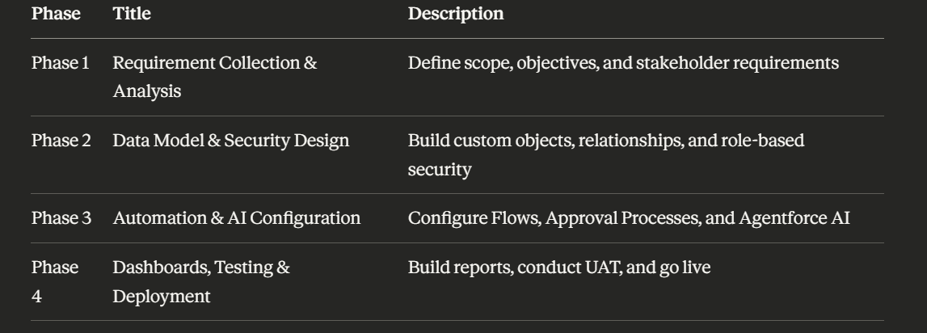

6. Success Criteria
The project will be considered successful when the following outcomes are achieved:
- A fully functional Salesforce recruitment application covering the entire hiring lifecycle
- AI-generated candidate scores and summaries are visible on all candidate records
- All offer approvals are routed through and enforced by the Salesforce approval process
- Role-based access is correctly configured so each stakeholder sees only authorized data
- Recruitment workflows (screening, scheduling, follow-up) are fully automated via Flows
- Dashboards and reports provide real-time pipeline visibility to recruiters and managers
- Zero custom Apex code is used — entire system built using declarative Salesforce tools.
7. Conclusion
Phase 1 of the AIRCMS project establishes a clear and comprehensive foundation for building an intelligent, automated, and secure recruitment management system on Salesforce. By defining the project scope, objectives, stakeholder roles, and success criteria at this stage, the project team ensures that all subsequent phases of development are aligned, purposeful, and measurable.
The AIRCMS solution is positioned to transform the recruitment function by replacing manual, inconsistent processes with AI-driven insights, automated workflows, and governance-enforced decision-making — all within the trusted and scalable Salesforce ecosystem.

